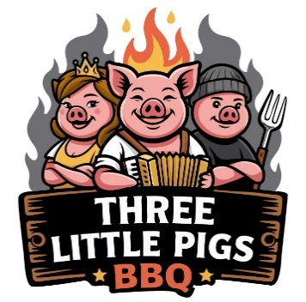

Three Little Pigs BBQ – Catering Menu

Smoked Meats (Choose 1–3)
- Smoked Pulled Pork – Hickory-smoked, house BBQ sauce
- Smoked Pork Ribs – Dry-rubbed & smoked
- Smoked Chicken Quarters – Juicy, seasoned & perfectly cooked
- Smoked Beef Ribs (Optional Premium) – Smoky, juicy, & tender
- Smoked Sausages- Italian Sausages, juicy & perfectly smoked

BBQ Combos
- Two-Meat Combo
Choose any 2 meats + 2 sides + rolls
- Three-Meat Combo
Choose any 3 meats + 3 sides + rolls
- Pig Out Package (Best Seller)
Pork ribs, pulled pork & chicken leg quarters + 3 sides + rolls

Classic Sides (Choose 2–4)
- Creamy Coleslaw
- Mac & Cheese
- Buttered Corn on the Cob
- Mashed Potatoes
- Esquites
- Macaroni Salad

Add-Ons
- Extra Meat (by the pound)
- Additional Sides (by the tray)
- BBQ Sauce Bar (Spicy and/or Sweet & Savory)
- Disposable Plates, Cutlery & Chafing Racks
- On-Site Serving Staff

Sandwich Bar Option
- Pulled Pork
- Brioche buns
- Pickles, onions & slaw
- Choice of 2 sides

Catering Details
- Minimum: 25 guests
- 48–72 hours advance notice required
- Full-service & drop-off available
- Deposits upon contract
- Full payment due 24 hours prior

